Lecture 17 | Issues in NLP and possible Architectures for NLP

* The unified theory of inference
  + System had 6 general forms of inference:
    - **Elaboration**: filling a slot to connect two entities
      * John got piggybank for REASON have money for REASON buy present
    - **Reference Resolution**
    - **View Application**: The Red Sox killed the Yankees
      * KILLED is not animal; KILLING is viewed as a DEFEAT-CONVINVINGLY
    - **Concretisation**: Infer more specific
      * TRAVELLING in an AUTOMOBILE is an instance of DRIVING
* What do we still need?
  + BiLSTMs with attention seem to be taking over the field and improving our ability to do everything
  + Neural methods are leading to a renaissance for all language generation tasks (i.e. MT, dialog, QA, summarisation…)
  + However:
    - We still have very primitive methods for building and accessing memories or knowledge
    - Current models have almost nothing for developing and executing goals and plans
    - We still have quite inadequate abilities for understanding and using inter-sentential relationships
    - We still can’t, at a large scale, do elaborations from a situation using common sense knowledge
* Political Ideology Detection using Recursive NN
  + TreeRNNs are theoretically appealing and empirically competitive but prohibitively slow and don’t exploit complementary linear structure of language – not very efficient with computation on GPUs
* Shift-reduce Parser-Interpreter NN (SPINN)
  + Base model is equivalent to a TreeRNN but supports batch speed-up
* Stanford Natural Language Inference corpus (fake new challenge)
  + You have a piece of text and then you have a hypothesis following it and you want to predict whether the hypothesis follows from the piece of text is an entailment, neutral or contradiction

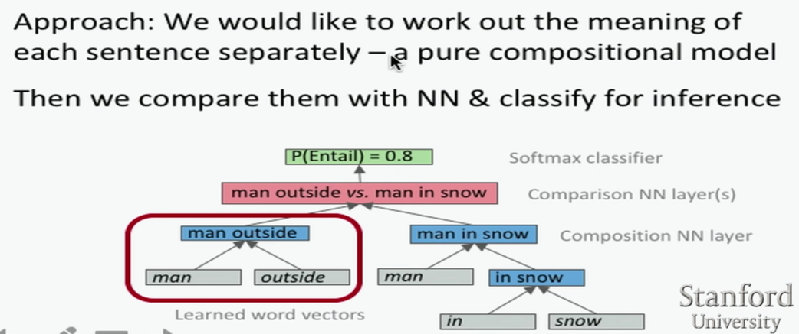

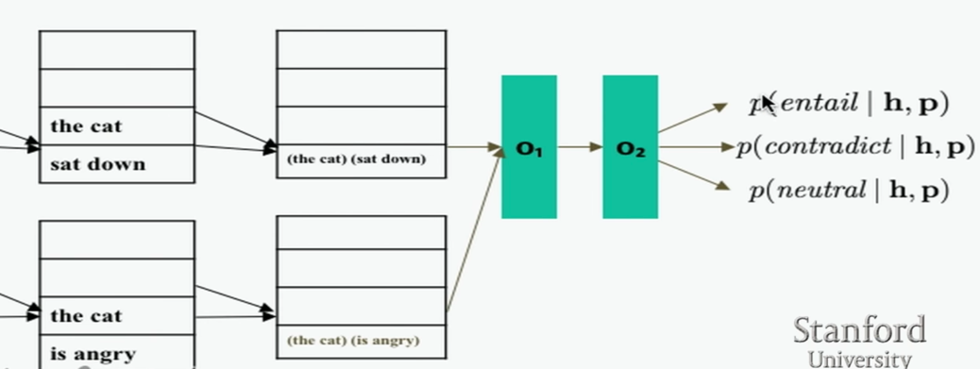

* Copying/pointer networks
  + Effective in tasks like summarisation as well
* Models below word level
  + When you need to handle large, open vocabulary
    - Rich morphology
    - Informal spelling (Tweets)
    - Transliteration
* Character-level models
  + Word embeddings can be composed from character embeddings
    - Generates embeddings for unknown words
    - Similar spellings share similar embeddings
    - Solves OOV problem